Red Cross Inspection
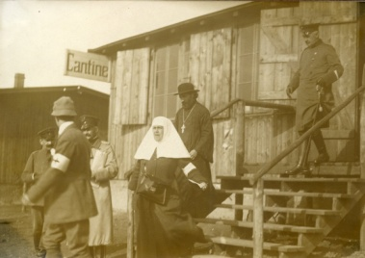
495 Inspection by Red Cross officials, a group consisting of a civilian, a probably Russian Orthodox priest and a Catholic nun.
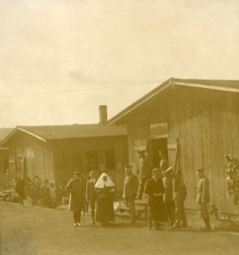
497 As 495
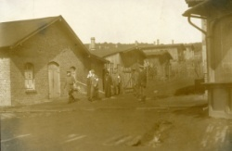
498 As 495

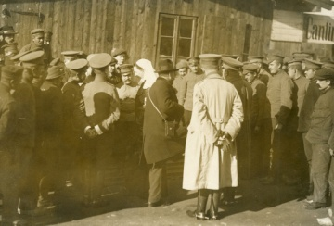
499 Apparently an inspection by a different group of the Red Cross. The nurse is surrounded by Russian soldiers, a French soldier is on the right and a German officer at the front.
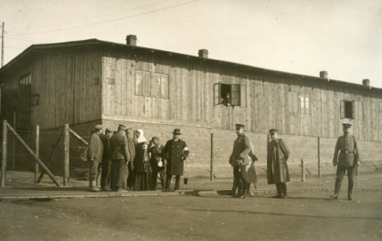
- As 499

Everett Sharp
Oxford University

