Hameln: Graveyard
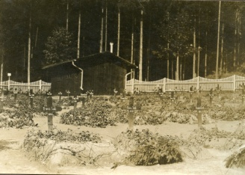
520 A graveyard for both non German military and civilian prisoners; it should be remembered that both sides interned most civilians of those countries with whom they were at war unfortunate enough to be on the wrong side of the border. At the front right a cross bears the inscription "Franz. Civil." – for French Civilian, other crosses are marked with "Franz. Sold." and "Russ. Sold." – French soldier and Russian Soldier. The numbers on the crosses proabably refer to a list of names.
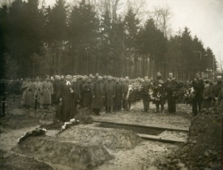
475 A funeral attended by many P.O.Ws’ plus German guards with a priest officiating. Although the greatcoats worn by the majority appear to be the Shinel design of the Russian army the men holding the wreaths are British soldiers and sailors, as Russian non-officer jackets when issued were pocket-less. The soldiers to the extreme right of the picture are French.
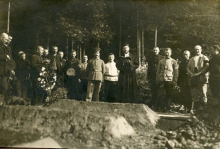
519 Possibly a picture of the same burial as in 475
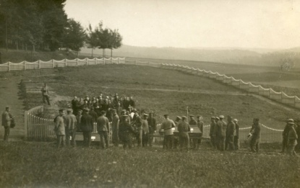
517 A funeral with numerous Russian soldiers

Everett Sharp
Oxford University

