P.O.W. Camp life

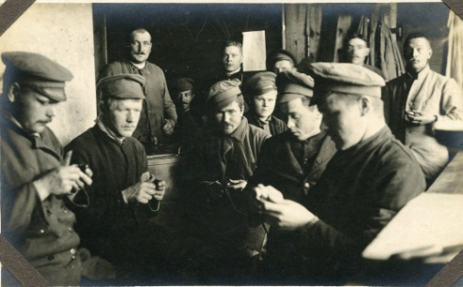
27 Russian P.O.Ws’

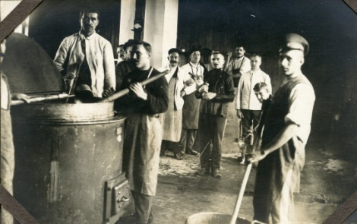
28 Cook house with Russian prisoners

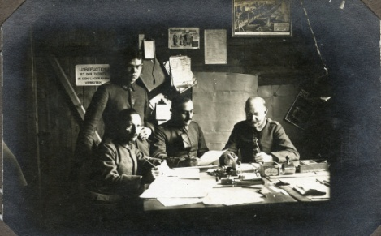
29 Senior German administrative staff.

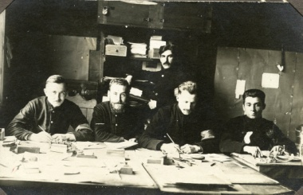
30 Possibly French prisoners, working in the camp post office.

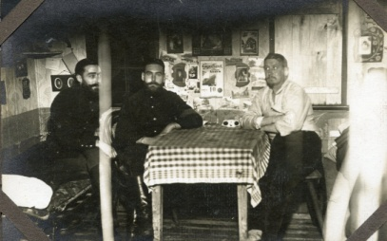
31 By the cut and buttons of the soldier on the left these are French prisoners.

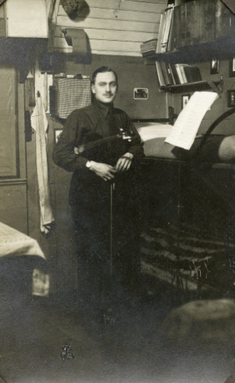
32 A Russian violinist.

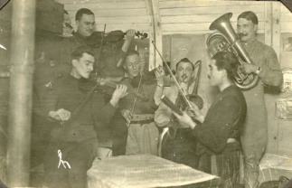
35 Russian musicians

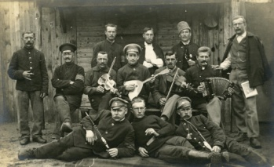
62 Russian musicians, one with a balalaika.

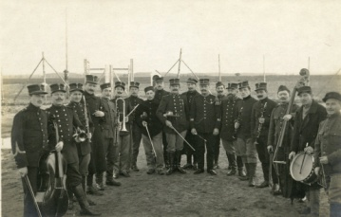
58 A well equipped group of Belgian musicians.

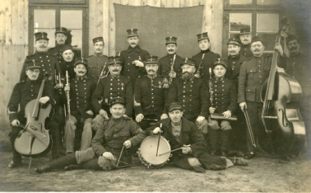
59 Belgian musicians
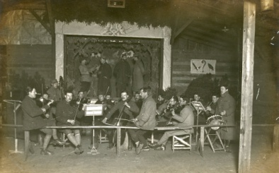
79 French musicians and a small stage.

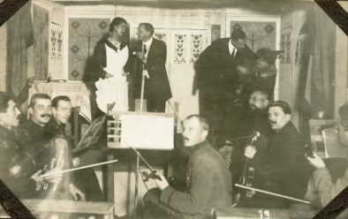
36 Musicians and the camp theatre, with one male prisoner dressed as a woman.

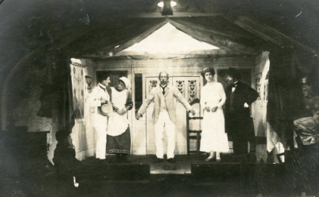
38 A play

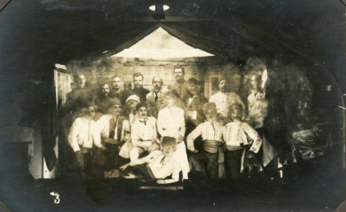
39 A play

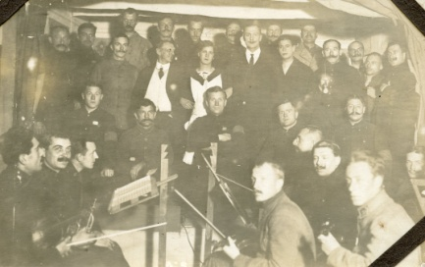
37 The cast of a play with Russian and French musicians

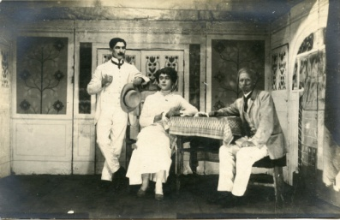
41 Another play, the young man who has been cast in the woman’s role looks rather convincing in the part. This play seems to be taking place in Munsterlager.

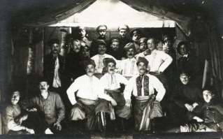
76 A Russian choir, also in Munsterlager.

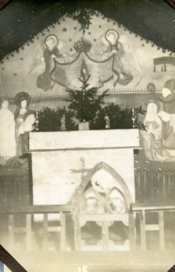
33 Christmas place of worship, with probable Orthodox iconography.
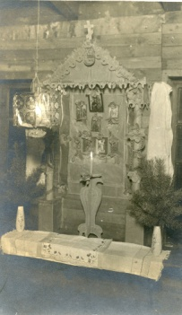
63 An Orthodox place of worship

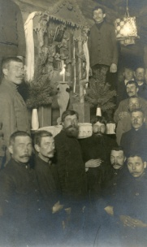
64 Orthodox place of worship with Russian soldiers and probably a priest standing in the middle.

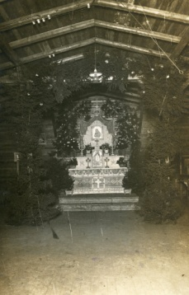
81 Orthodox place of worship

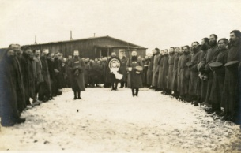
82 An Orthodox service with priest and Russian soldiers

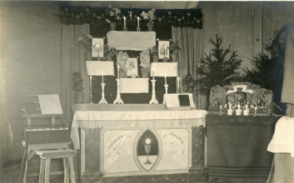
45 Christmas worship
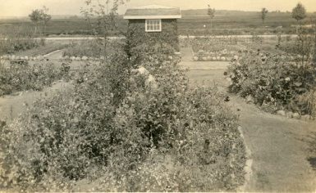
47 A general view of a camp garden
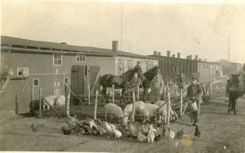
48 The camp farm, with German soldiers and a Russian ‘pig man’ feeding his stock.
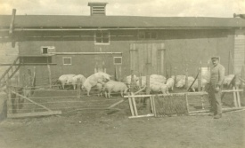
49 The pig farm.
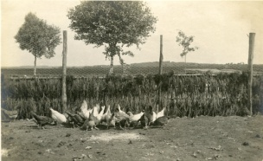
50 The chicken farm

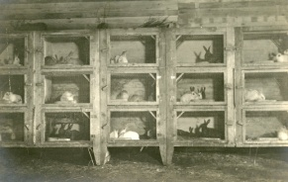
51 Rabbits

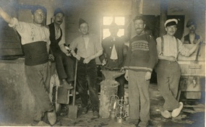
52 The Blacksmiths , with French and Russian prisoners.

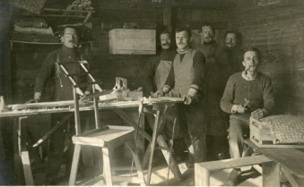
53 Working with wood.

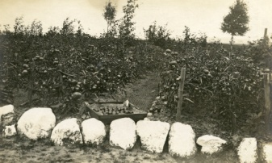
54 Vegetable garden

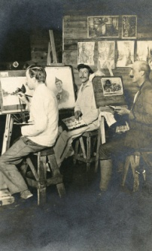
55 An art class with French soldiers.

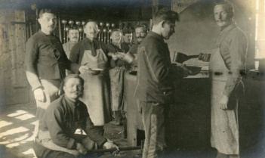
56 The cook house with Belgian POWs’

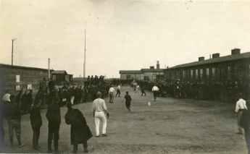
57 A sports event
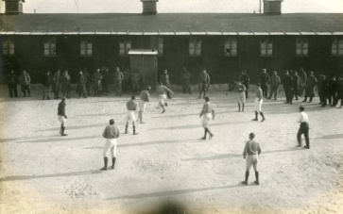
74 Football for the P.O.Ws’

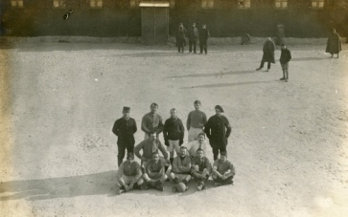
75 The French team

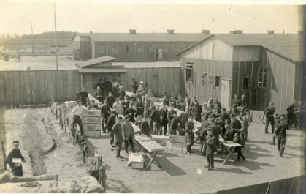
60 Red Cross packages being received by Belgian POWs’
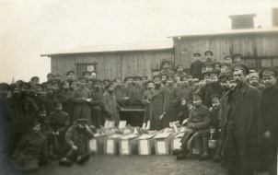
61 Red Cross packages being received by Russian POWs’
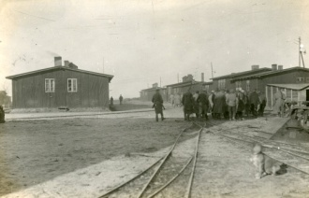
68 POWs’ under Landsturm guard walking over the rails of the camps light railway system, clearly indication the size of the camp and the amount of work required to administer it. Probably the camp in Ahlen-Falkenberger Moor.
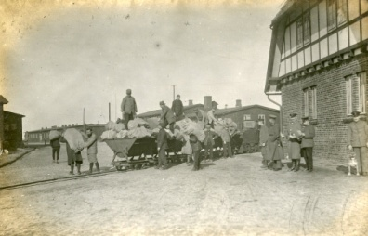
69 French POWs’ and their German guards unloading trucks from the light rail system.
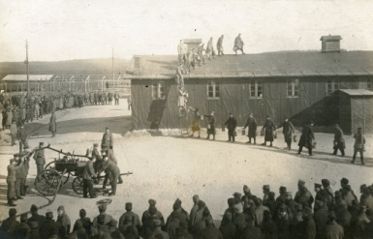
73 Fire practice with Germans manning the pump and one supervises the French ‘fire brigade’ handing up water buckets to their colleagues on the roof.

Everett Sharp
Oxford University

